

A Project Report On

**SMART CONTACT MANAGER**

**By**

UDHAYANITHIT

VIJAYALAKSHMI D

NAGALAKSHMI M

ARUN KUMAR T

SUBRAMANIAN E

**Batch:** 2021 – 6260

**Center: Chennai**

Under the Guidance of,

**Mr. Rahul Gaba**

**Technical Trainer**

## EduBridge

(Capgemini Certified Java Full Stack Professional)

### Introduction

If you have a new member on your staff, it's easy to share all your business contacts. Or if you need to transfer contact data from one account to another, Smart Contact Manager can do it in a single click, synchronizes all data.

Smart Contact Manager provides a wide range of remote development services and has a clear goal to help startups and companies solve various tasks regardless of the level of complexity and scale.

Smart Contact Manager store your contact in modern way.

.

**MODULES:-**

* **Home Module**

* **About Module**

* **Sign-up Module**

* **Login Module**

I developed this Project with the help of **Java, JPA Hibernate, STS Tool MySQL.** It’s a web-based project with both frontend and backend Technologies like **HTML, CSS, JavaScript and Bootstrap** also.

The main objective of the project on Smart Contact Manager is to manage the details of phone number, name, Email id, work, profile. It manages all the information about users details.

The project is totally built at administrative end and thus only the administrator is guaranteed the access. The purpose of the project is to build an application program to reduce the manual work for managing the phone number, name, Email id, work, profile. It tracks all the details about the users.

In Home Module, There are three Options About Module, Sign Up module, and Log In Module. We can Open each module and perform Sign Up and Log In operation in it. Each Module Gives Different Modularity.

In Sign Up Module, Users can register their name, phone number, Email Id, work. Here, User can create their own password.

In Login Module, Users can check their name, phone number, Email Id, work all the detail are register or not. If the user forgot their own password, here they can easily reset the password.

**Hardware Requirement:**

* I3 Or I5 Processor
* 4 Gb Ram
* 100 GB Hard Disk
* Windows 10 OS

**Software Requirement:**

* **Front End**: Html, Css, Javascript
* **Back End**: Spring Boot AND Jpa Hibernate
* **DB Server**: Mysql Server 8.0.Ce
* **Web Server**: Apache Tomcat
* **IDE**: Spring Tool Suite(sts)
* **Browser**: Google Chrome OR Ms-edge

### Data Dictionary

* CREATE Database smart contact;

* CREATE TABLE user (id int, name varchar(255), about varchar(500), email varchar(255), image_url varchar(255), enabled bit(1), password varchar(255), role varchar(255), user_id int, user_name varchar(255), user_about varchar(500), user_email varchar(255), user_image_url varchar(255), user_enabled bit(1), user_password varchar(255), user_role varchar(255));

* CREATE TABLE user_contacts (user_id int, user_ user_id int, contacts_cid int);

* CREATE TABLE contact (cid int, name varchar(255), phone varchar(255), email varchar(255), description varchar(255), second_name varchar(255), work varchar(255), user_id int, user_user_id int);
* CREATE TABLE hibernate_sequence (next_val bigint);

**Screenshots**

1. **Home Module:**

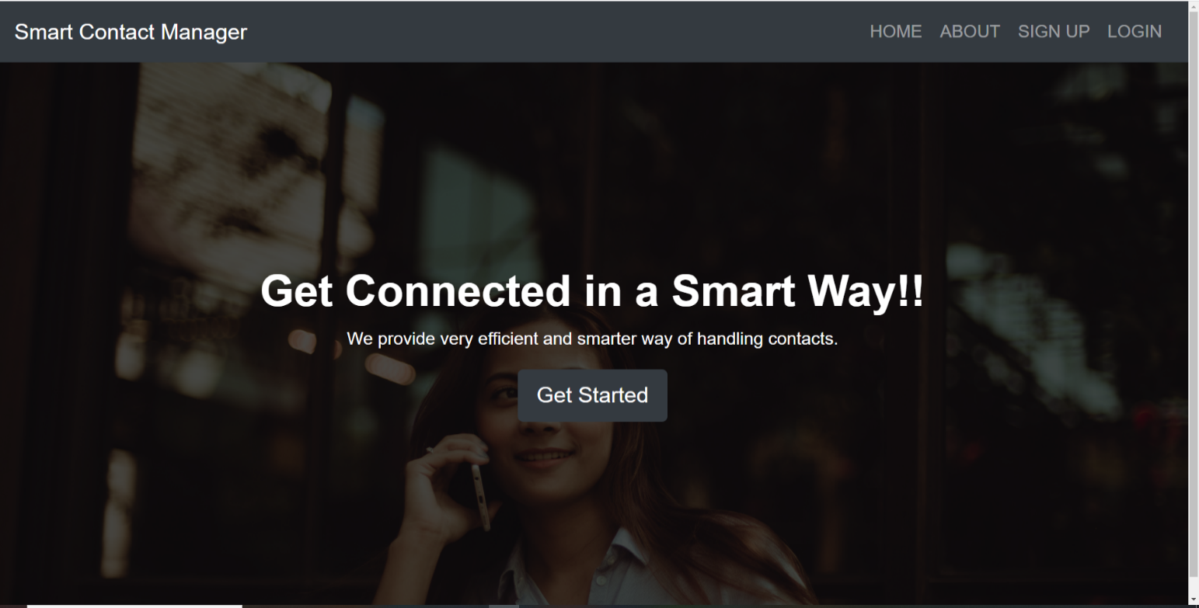

1. **About Module:**

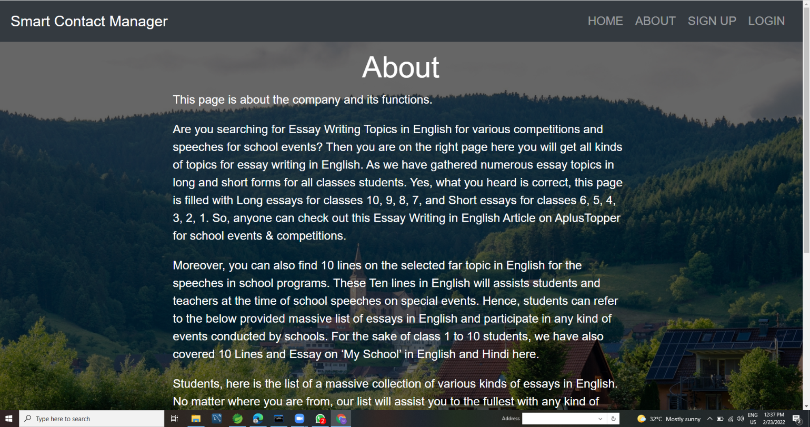

**2.Sign-up Module:**

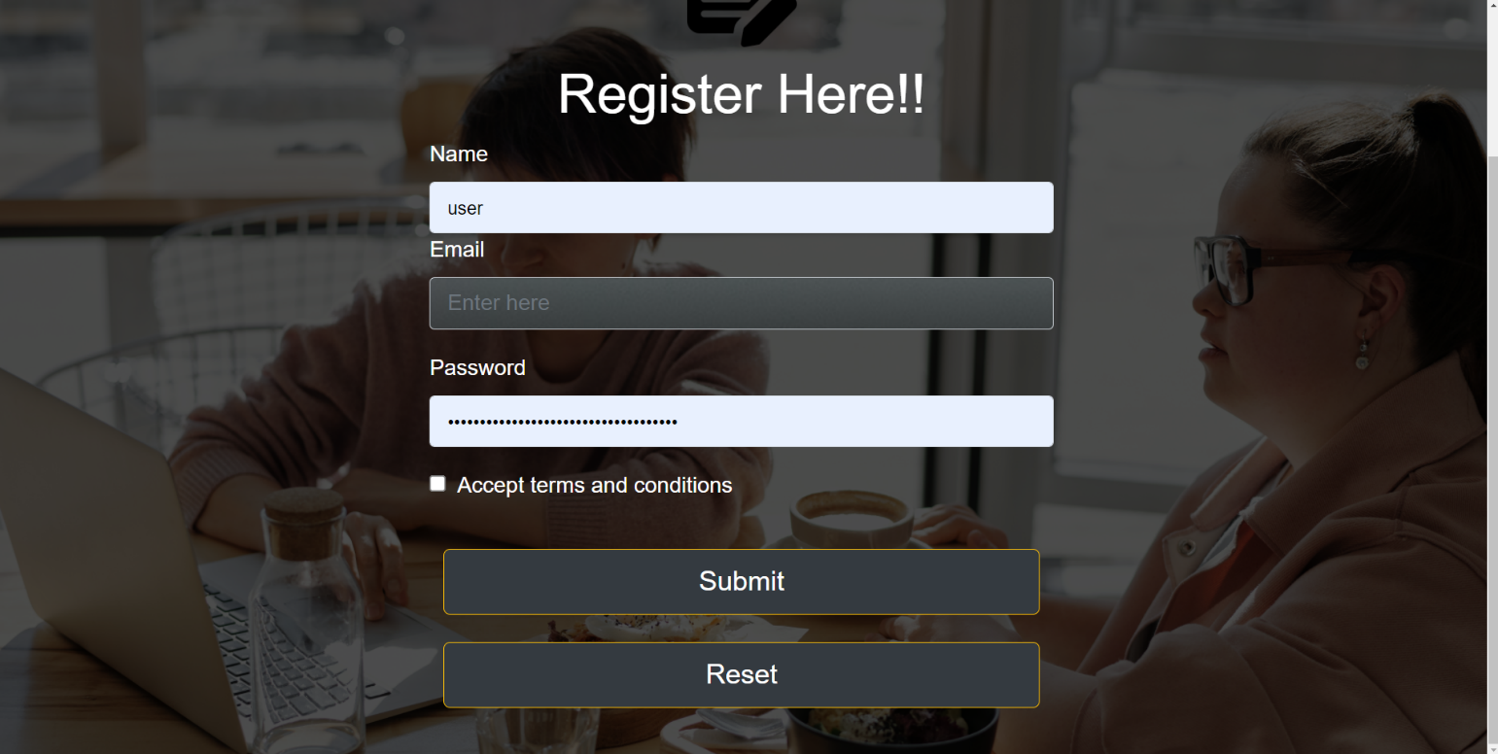

**3.Login Module:**

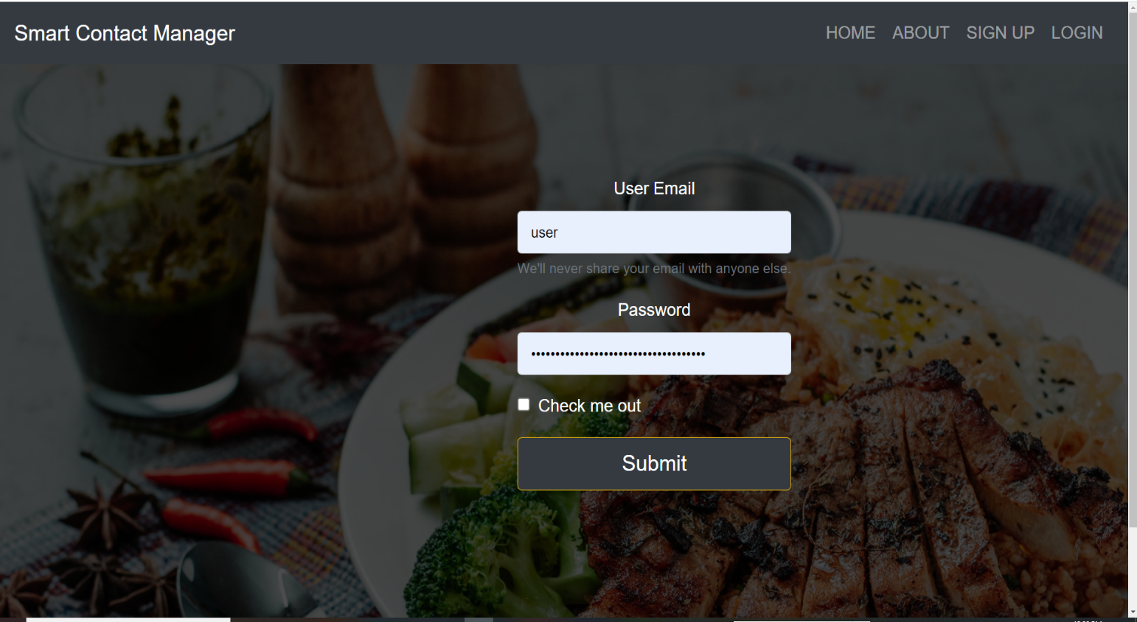

**4.Dashboard Module:**

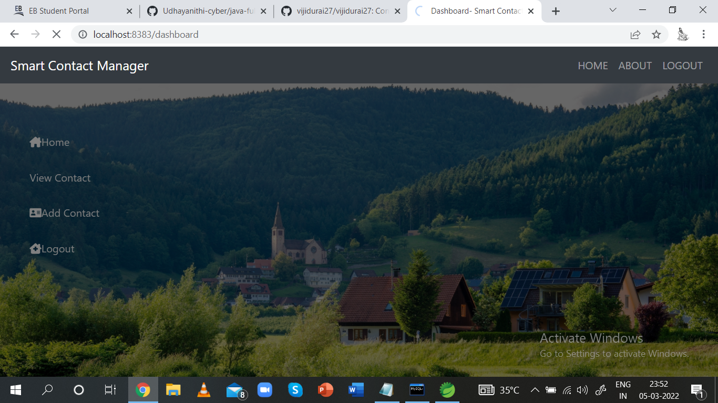

**5.Adding Contact:**

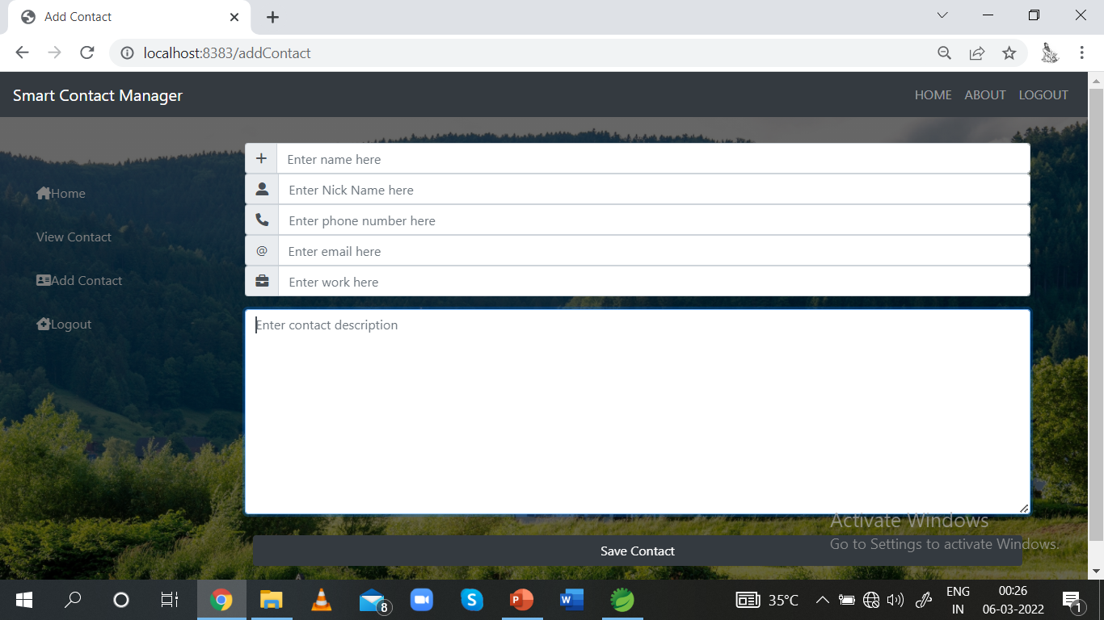

**6**.**View Contact:**

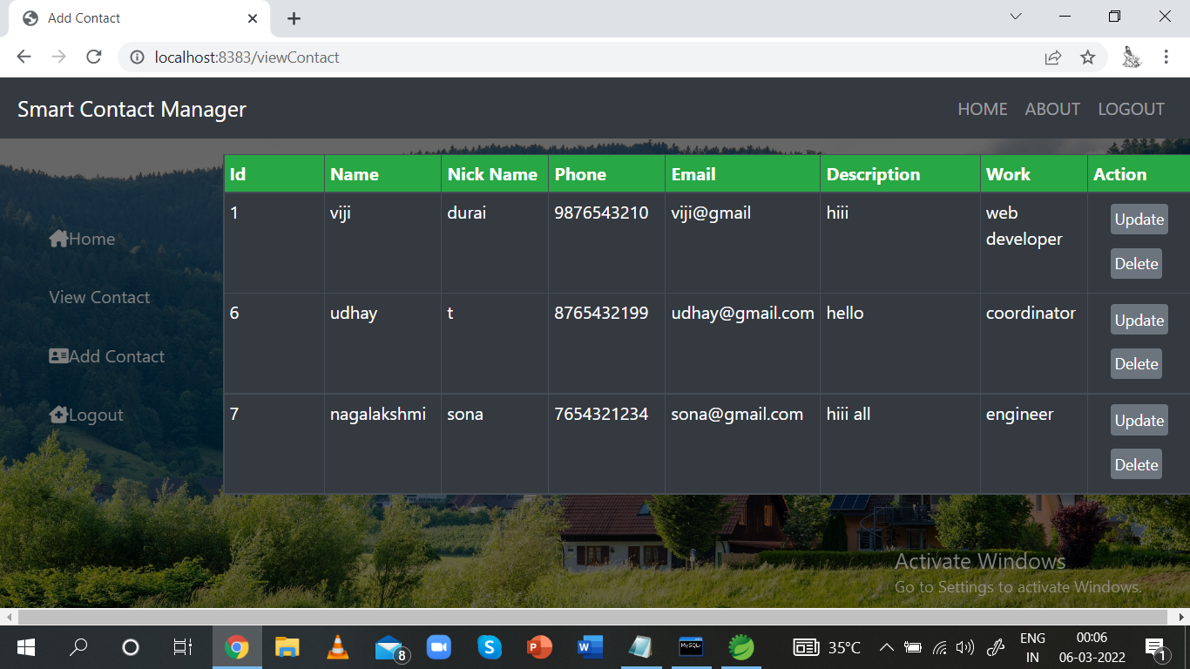

### Database Directory

**1.User Database:**

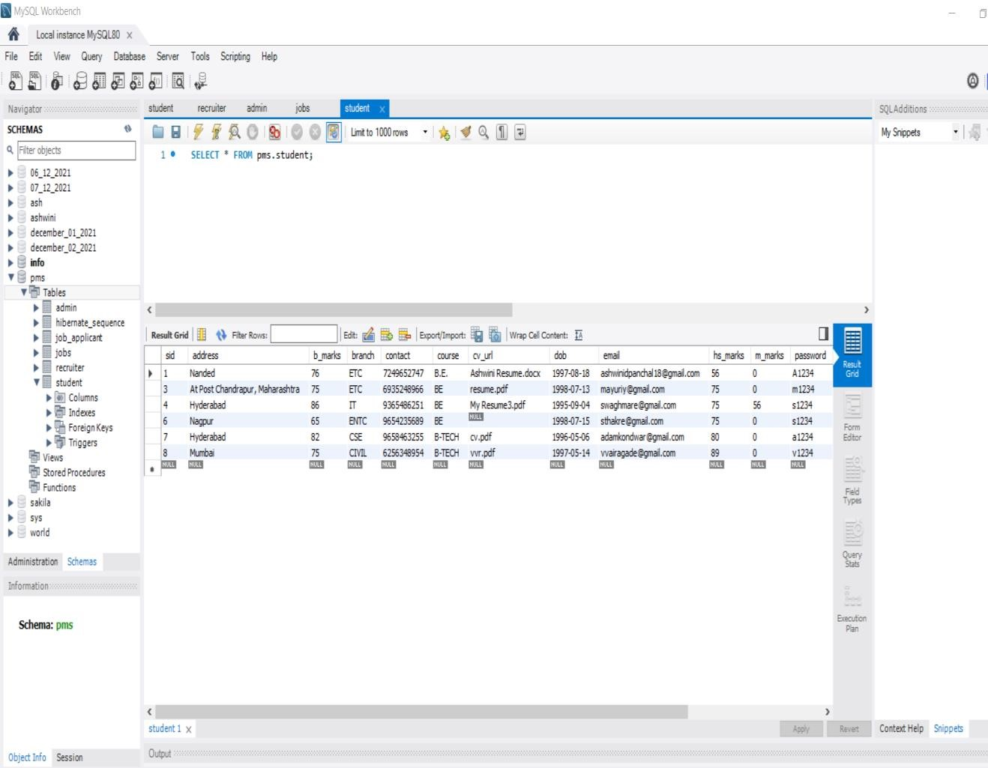

**2.User-contacts Database:**

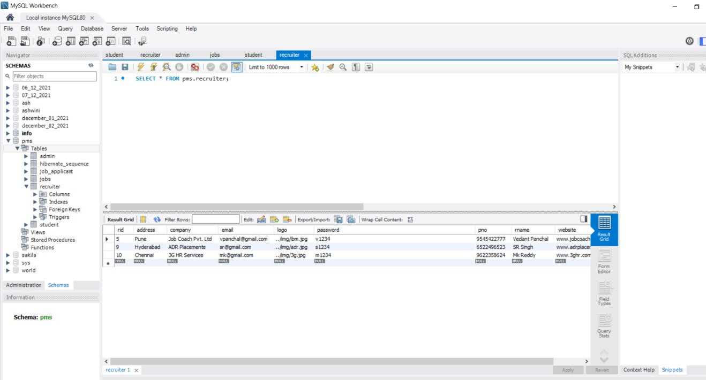

**3.Contact Database:**

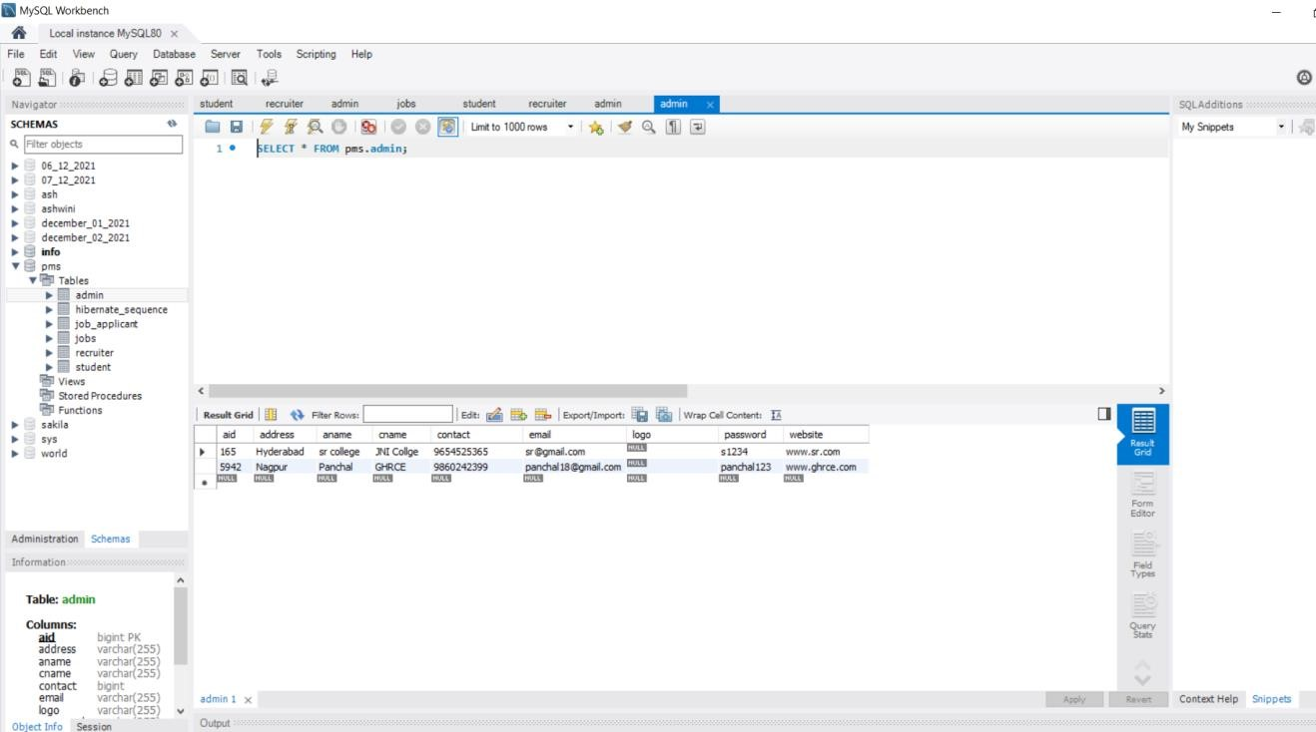

**4.Hibernate Database:**

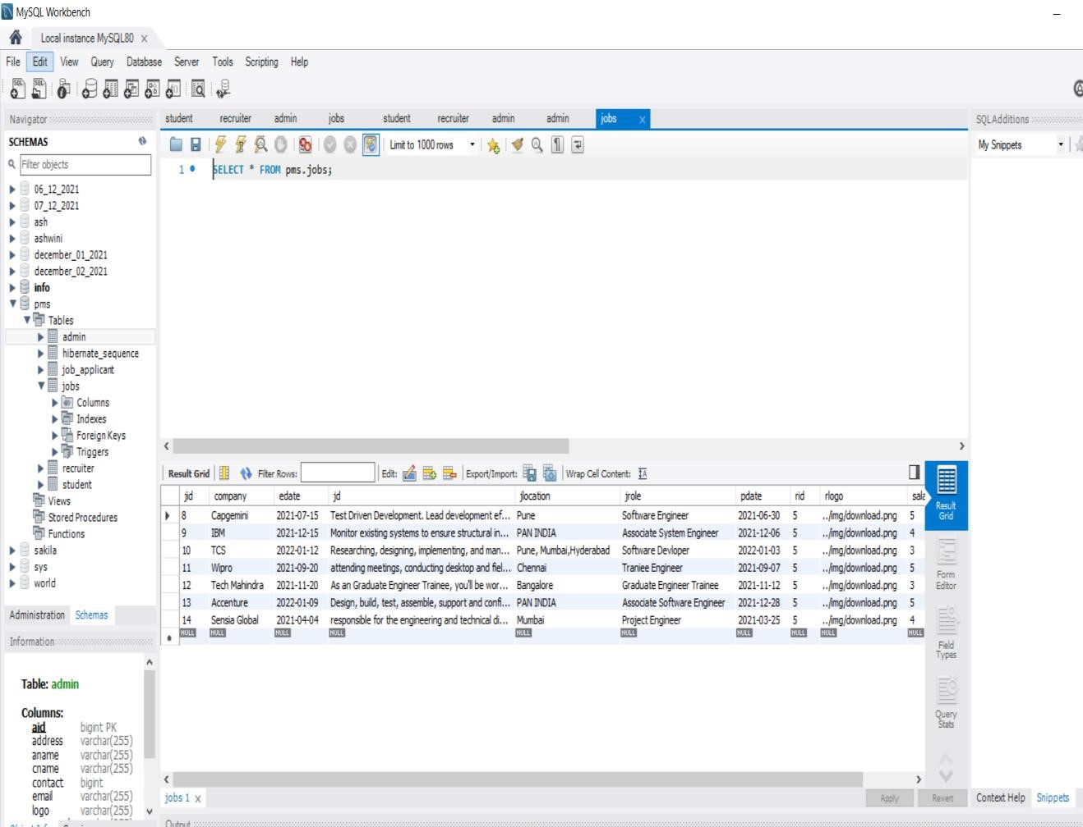

### Conclusion

In this project presentation, we explained the system design, requirements and implementation and the modules we have done till now. In accessing the outcome of this system, we have come to the final conclusion that Smart Contact Manager is more convenient than normal Contact Process or System

### References

* www.tutorialspoint.com
* software engineering (roger s. pressman)
* java complete html
* www.wikipedia.com

# Thank You